How to Run the Faculty Annual Review Reports

Step 1: Get a list of the tenured faculty and a list of the tenure track faculty in your department.

Step 2: Login to Digital Measures

Step 3: Select Reports across the top menu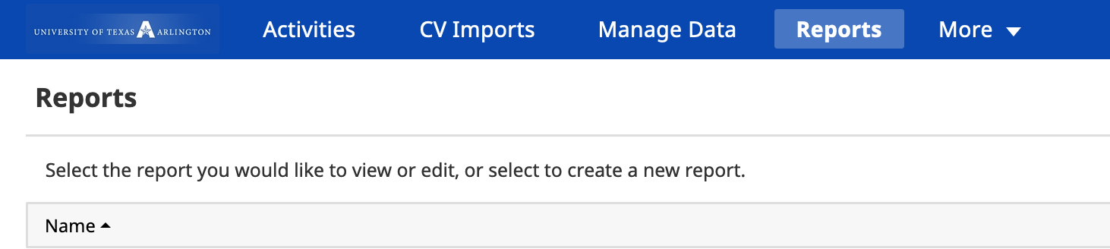

Step 4: Scroll down to the bottom of the list and select Tenure Track Faculty Evaluation for tenure track faculty.

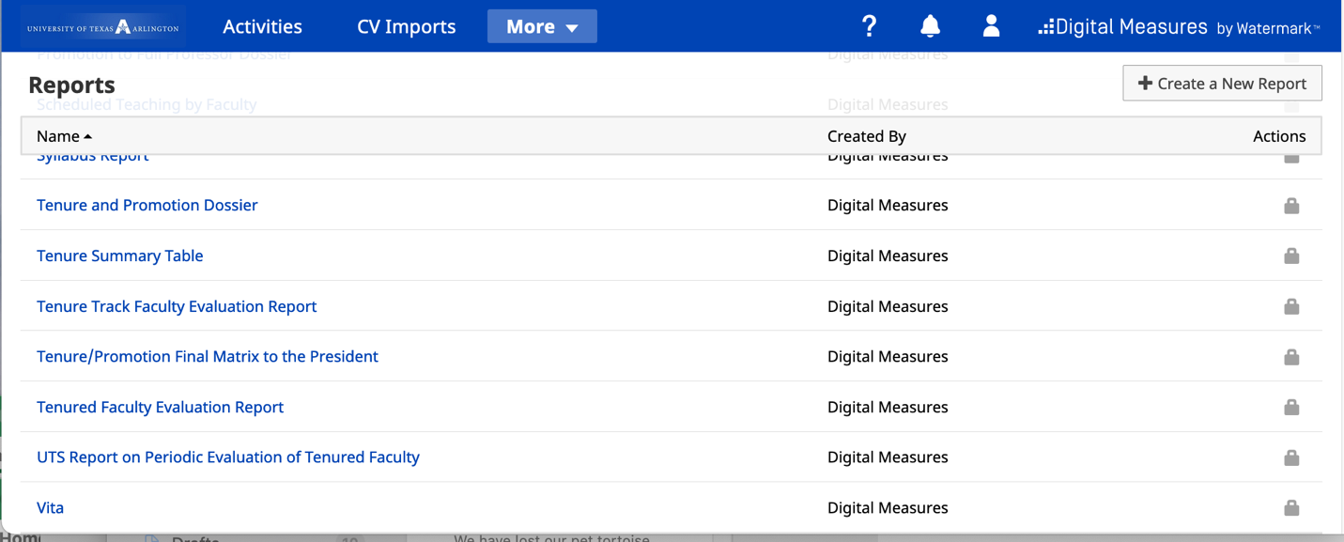

Step 5: Change the dates to the fiscal year for the report that you want. For the 2019-2020 review year the start date is 1 Sep 2019 and end date is 31 Aug 2020.
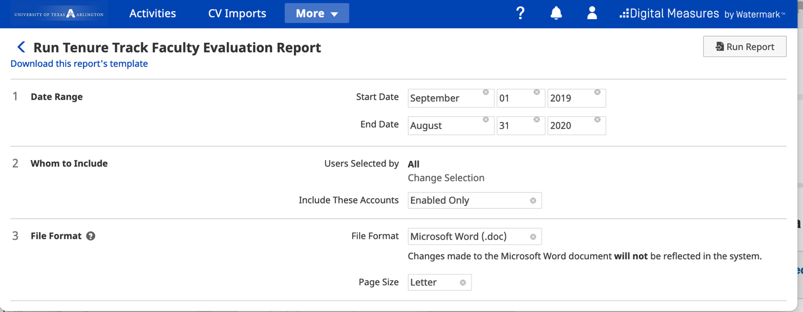

Step 6: Click on Change Selection

Step 7: Click on the arrow next to Individual
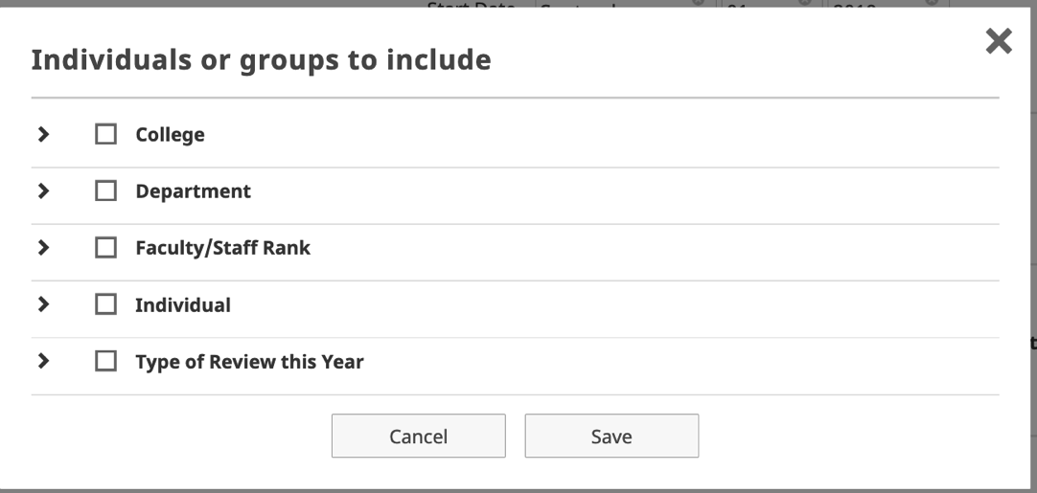

Step 8: Click the box next to the name of each of your tenure track faculty members.
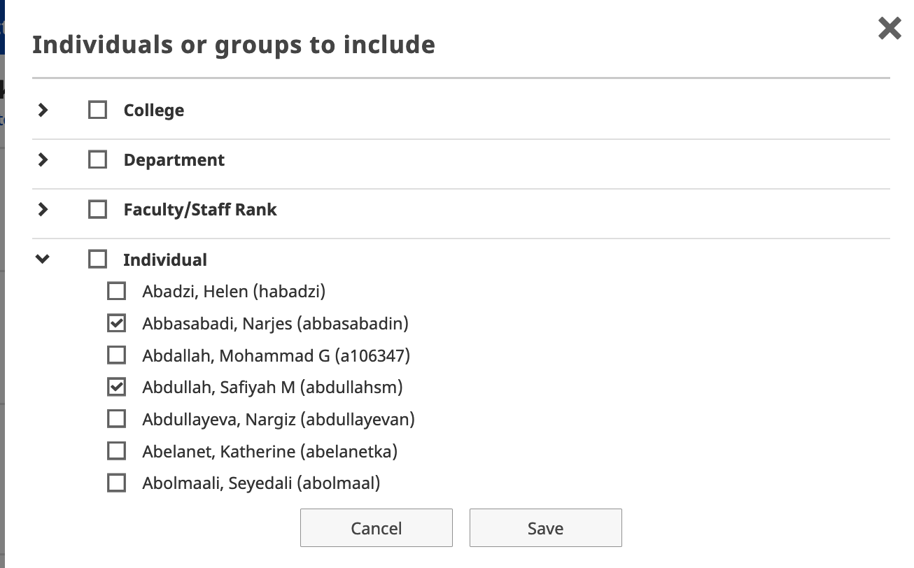

Step 9: Click on Save

Step 10: Click on the top right “run report”

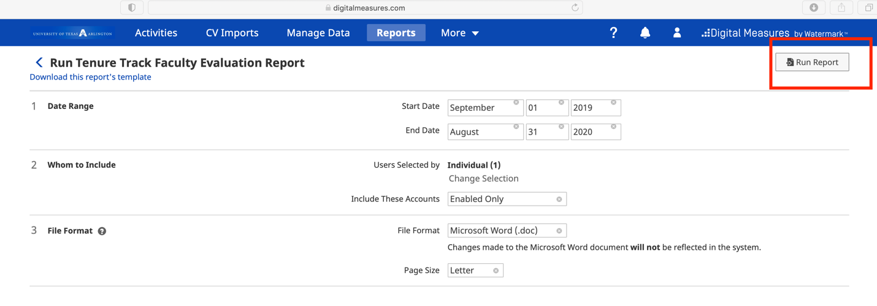
Step 11. Click on OK

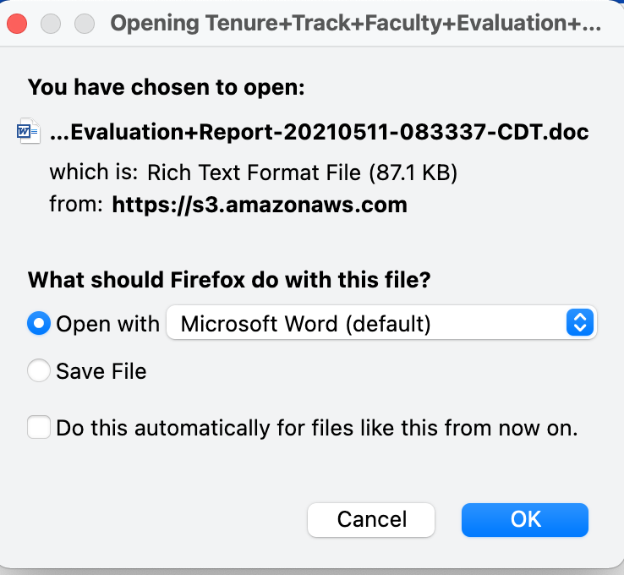

Step 12: The top of the report should look like this. Be sure to check that it says Tenure Track and that the Evaluation Period is 2019-2020. Switch the file format to landscape and save as a PDF.

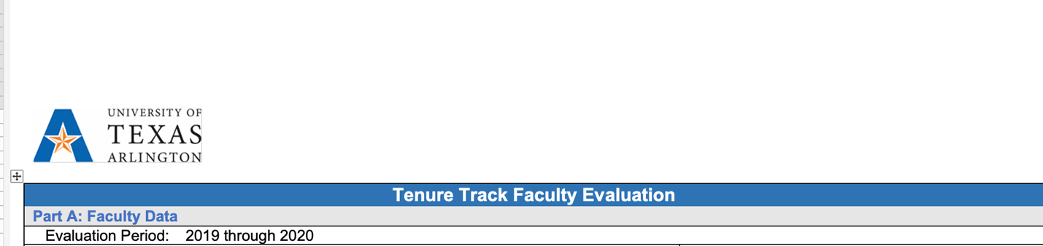

Step 13: Email a copy of the PDF file to the individual faculty member and copy the department chair on the email. Please remind the faculty member to upload this file into their Digital Measures account so it will be there for future evaluations.

For Tenured Faculty the process is the same except select the Tenured Faculty Evaluation Report.

